|  |
| --- |
| IT1B |
| Project Innovate |
| A smart solution to finding friends for your dog |
| Philip, Hylke, Hemran, Muhitdin, Patrick, Nadie  5-10-2019 |

# Content

## Background

## Project Results

## Project Activities

## Quality Control

## Project Organisation

## Planning and Scheduling

## Costs and Benefits

## Risks

# 1. Background

IT1B was initially contacted by their client and given the assignment to create an innovative solution to a modern problem in the IT world.

Following this, a solution was conceptualized to combat the growing problem of dog owners not being able to find a suitable companion for their pet; An app has to be developed to facilitate this process and mediate between owners to establish a safe environment.

The client has specified a number of boundaries, such as a desired date of completion, in order to ensure the success of the project. Regular communication between the client and the developing team will also be necessary to keep the project’s features and specifications in line with the client’s wishes.

Management of the developing group is accomplished by a team leader, co-leader and secretary role. They will manage the progress of the project, communications with the client and proper documentation of the various tasks executed.

# 2. Project Results

We as a Group decided for the Project Breedr.   
Breedr will be an Application for Android, which is written in PHP and then converted into a java app on Android Studio.   
  
This Application is for dog owners who would like their dogs to meet and play and optionally to propagate.   
The Application will have the following features:

* A **Profile** page for each user to fill out
* A **settings** page for each user to set search parameters
* A page for users to **“like” or “dislike”** profiles from their search results
* An AI to **verify** the pictures uploaded to users’ profiles
* The ability to **chat** with users that have been matched

The **main goal** is therefore to have the app working on the Android platform, with the features specified above, without any major bugs or glitches and at least 10 concurrent users by the 28th of June.

The optional goal is to add an AI/algorithm which analyses users’ preferences and uses the data to present search results for each user in a personalised order.

To conclude the project there will be a presentation and demonstration for the client.

# 3. Project activities

**Thinking phase**

- Time Management

Set dates and times for given tasks (divided within the group) and meetings.

- Weekly meetings

We will have at least one group meeting every week, to check up on progress.

Furthermore, we will decide when we need meeting with the client in order to fulfil information about the project

- Client meetings

Prepare questions for the client.

Take notes during the client meeting.

- Research

Brainstorm for ideas, everyone should take a participation and give at least one idea. Then the members of the group will choose top ideas and share it with the client to choose top two ideas as a Plan A and a plan B.

- Presentation

Present the Ideas of top projects to the client.

- Project plan

Divide chapters between group members.

Review project plan with group to finally hand in a draft version.

Depending on draft review, make improvements for the final version.

**Execution phase**

- Client meeting and Information

Ask questions and take notes during meetings.

- Design

Members who are responsible for Application will make a design and elaborate it with other members of group

- Coding & Testing

Create a functional application with AI and geolocation and test all its functions.

- Checking

Make sure everyone is on track and everyone is doing what he or she is supposed to.

**Final phase**

- Client meeting

Show completed product to the client and take notes to adjust accordingly.

- Presentation

Present the final product to the client

# 4. Quality

A checklist (See *appendix*) has been set up by group IT1B to ensure the quality of the

product is delivered. This will also ensure the project to be of a high

quality with a low risk of failure.

There will be weekly meeting in order to discuss the progress and results

of the project. During these meetings there will be opportunities to give

each other feedback in order to help us better understand the final

product you desire and would like us to achieve for you.

The project leader has the power to stop the project and have everyone take

a pause if the project is not up to the desired standard, the client also

has this authority.

Several measurements are being taken to ensure a perfect end product:

Shadow Test - This test is an objective method of investigating,

diagnosing, and evaluating refractive errors. This will show us the

desired results for the project.

Usability Test - This test will ensure that it’s a user-friendly, clear

and easily accessible for everybody.

Monkey Test - During this test group IT1B will break everything and find

out what breaks and also find out the reason behind it.

All the tests will be discussed and if the results are not meeting the

client and group expectations. The product will therefore be checked

and changed wherever it is necessary in order to meet the expectations

of the project.

# 5. Project Organisation

|  |  |
| --- | --- |
| **Role** | **Contact Information** |
| Leader | Name: Philip Blesinger  Email: philip.blesinger@student.nhlstenden.com |
| Co-Leader | Name: Nadie Sanli  Email: nadie.sanli@student.nhlstenden.com |
| Secretary | Name: Hylke Westerdijk  Email: hylke.westerdijk@student.nhlstenden.com |
| Developer | Name: Hemran Akhtari  Email: hemran.akhtari@student.nhlstenden.com |
| Developer | Name: Patrick Simion  Email: patrick.simion@student.nhlstenden.com |
| Developer | Name: Muhitdin  Email: muhitdin@student.nhlstenden.com |

**Leader:** Leader of IT1B, expected to be responsible of the project and IT1B.

**Co-Leader:** Co-Leader of IT1B, expected to take responsibility of the leader if the leader is not available or ill.

**Secretary:** Secretary of IT1B, expected to create notes and write down all that is discussed during and between meetings.

**Developer:** Developer of IT1B, expected to do the main part of programming and research required for the project.

**Short Term Communication:** Communication over short term is done via Whatsapp between group members as well as group members meeting up at least 3 times a week.

**Long Term Communication:** Communication over long term is done via email with both group members and clients.

**File Sharing:** Common documents such as word documents or excel spreadsheets will be shared and saved on a private Google Drive and programming documents will be shared and saved on a private GitHub repository.

**6. Planning and Scheduling**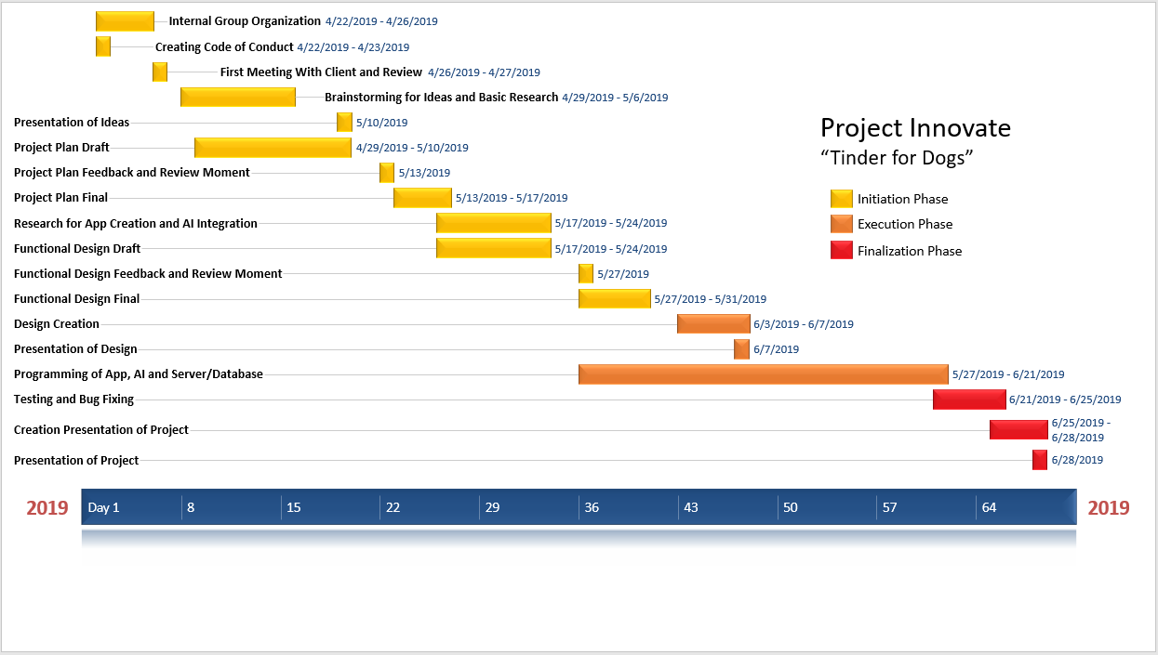

# 7.Costs and Benefits

In the beginning the group’s costs will have to be only regarding the server (setup and hosting) and paying for an online course in order to gain sufficient knowledge about artificial intelligence for successfully developing the application. When the final result of the application will be ready to be released, the group will have to invest into publishing the app on one of the 3 markets namely: Play Store(Android), App Store(IOS), Microsoft Store(Windows). After the publishing is done, the group will have to promote the app by paying for Advertisements. The benefits the group is going to have after publishing the App are going to overcome the costs by far.

**Costs (App Development)**

|  |  |  |
| --- | --- | --- |
| **Details** | **Cost** | **Frequency** |
| Server setup and configuration | 120$ | Once |
| Hosting | 30$ | Per month |
| Online course for learning AI | 20 – 99$ | Once |

**Costs (After App is finished)**

|  |  |  |
| --- | --- | --- |
| **Details** | **Cost** | **Frequency** |
| Publishing the app | Play Store 25$ | Once |
| App Store 99$ | Per year |
| Microsoft Store 12 - 99$  (depending on the account type) | Per year |
| Marketing (Promoting the app with Advertisements) | 9000$ | Per year |
| **Total (first year)                             9156$ (Minimum) 9322$ (Maximum)** | | |
| **Total (after first year)                   9111$(Minimum)     9198$ (Maximum)** | | |

**Benefits (After App is finished)**

|  |  |
| --- | --- |
| **Details** | **Benefits** |
| Considering the fact that the application is going to be used by most of the dog owners | 1$ per user |
| Premium account | 4$ monthly per user with premium account |
| Promoting other applications with Advertisements | 1$ per Advertisement |
| **Total (for 100k users with normal account considering 1 Advertisement per use and 20 uses per user)** | **Approx. 2M$ per year** |
| **Total (for 100k users with premium account with no Advertisements)** | **Approx. 4.8M$ per year** |

# 8. Risks

|  |  |  |
| --- | --- | --- |
| **Risk** | **Prevention & Damage Control** | **Priority** |
| Several members in the group are absent due to sickness | Leader group should have an overview of absent people and split the workload to other members within the group | Mid |
| Server crash | Efficient and effective code as well as testing and monitoring | High |
| Loss of data | Consistent use of GitHub and offline backups | High |
| Insufficient communication / miscommunication within the group | Clear and specific goals as well as meetings in case of miscommunication | Mid |
| Couldn’t finish project on time | Run the idea through the SDLC and study the feasibility | High |

# Appendix 1: QA Checklist

|  |  |  |
| --- | --- | --- |
| Testing / Quality checklist | | |
| This checklist will ensure a high quality product with a low risk of failure. | | |
|  | **DEVICE CHECKS** |  |
| **#** | **Description** | **Status** |
| **1.1** | Can the app be installed on the device? |  |
| **1.2** | Does the app behave as designed/desired if there is an incoming call? |  |
| **1.3** | Does the app behave as designed/desired if there is an incoming SMS? |  |
| **1.4** | Does the app behave as designed/desired if the device goes to sleeping mode |  |
| **1.5** | Does the app behave as designed/desired if the device resumes from sleeping mode |  |
| **1.6** | Does the app behave as designed/desired if the device resumes from lock screen? |  |
| **1.7** | Does the app behave as designed/desired if the device is tilted? |  |
| **1.8** | Does the app interact with the GPS sensor correctly (switch on/off, retrieve GPS data)? |  |
| **1.9** | Is the functionality of all the buttons or keys on the device defined for this app? |  |
| **1.10** | Verify that buttons or keys which have no defined function have no unexpected behaviour on the app when activating. |  |
| **1.11** | In case there’s a true “back” button available on the device does the “back” button takes the user to the previous screen? |  |
| **1.12** | In case there’s a true “menu” button available on the device, does the menu button show the app’s menu? |  |
| **1.13** | In case there’s a true “home” button available on the device, does the home button get the user back to the home screen of the device? |  |
| **1.14** | Does the app behave as designed/desired if the device is in airplane mode? |  |
| **1.15** | Can the app be found in the app store? (Check after go-live) |  |
| **1.16** | Does the application function as expected after re-installation? |  |

|  |  |  |
| --- | --- | --- |
|  | **APP CHECKS** |  |
| **#** | **Description** | **Status** |
| **2.1** | Has the app been tested on different types of devices and different versions of OS? |  |
| **2.2** | Stability check: if the app has a list (for instance of pictures) in it, try scrolling through it at high speed. |  |
| **2.3** | Stability check: if the app has a list (for instance of pictures) in it, try scrolling to before the first picture or behind the last picture. |  |
| **2.4** | Is downloading of the app prevented in case it’s bigger than the OS allows downloading when connected to cellular networks. |  |
| **2.5** | Integration: does the app connect correctly to the different social networks (LinkedIn, twitter, facebook, etc). |  |
| **2.6** | The app does not interfere with other apps when in background/multitasking mode (using GPS, playing music, etc.). |  |
| **2.7** | The search option in the app displays relevant results |  |
| **2.8** | Verify most common gestures used to control the app. |  |
| **2.9** | What happens if you select different options at the same time (undesired multitouch, for example – select two contacts from the phone book at the same time). |  |
| **2.10** | Does the app limit or clean the amount of cached data. |  |
| **2.11** | Reloading of data from remote service has been properly designed to prevent performance issues at server-side. (manual reloading of data can reduce the amount of server calls) |  |
| **2.12** | Does the app go to sleep mode when running in the background (prevent battery drain) |  |

|  |  |  |
| --- | --- | --- |
|  | **UI/UX CHECKS** |  |
| **#** | **Description** | **Status** |
| **3.1** | To keep controls as unobtrusive as possible for instance by fading them out if they are not used for a while. |  |
| **3.2** | Make it possible for users to go back to a previous screen for instance by adding a back or cancel button |  |
| **3.3** | The main function of the app should be apparent immediately. It should speak for itself. |  |
| **3.4** | Use at most one action on the screen that is highlighted as the most likely for the user. |  |
| **3.5** | Minimize user actions by using a picker or a table view where users can select a certain choice over a data entry field where users have to type a choice |  |
| **3.6** | In an app, the user should not be exposed to the permissions of a specific file |  |
| **3.7** | If there is a long list of data to scroll trough, provide a search option above the list. |  |
| **3.8** | If performance is slow, indicate a progress status icon (“Loading…”), preferably with specific message. |  |
| **3.9** | In case of ‘live’ filtering of data while the user enters his search query, verify the performance. |  |
| **3.10** | The appearance of buttons that perform standard actions are not altered in the app (for instance: refresh, organize, trash, Reply, back, etc.) |  |
| **3.11** | Do not redefine gestures in your app that have a standard meaning (example: swiping from top to bottom enables the notification center) |  |
| **3.12** | Requirement to login is delayed in the app as long as possible |  |
| **3.13** | If the app is stopped at an unexpected time, user data should be saved locally and available at start-up. |  |
| **3.14** | Keyboard adjusts to expected input (for instance numbers/letters when expected). |  |
| **3.15** | Are inactive buttons clearly distinguished from active buttons? |  |